# On-Demand Services

Finding workers for simple home repairs like plumbing and electrical is expensive as well as complex. A web app idea that can tackle this problem is an on-demand services app. Consumers may access several home services using a single web app.

# Database design

This app can revolve around this simple design:

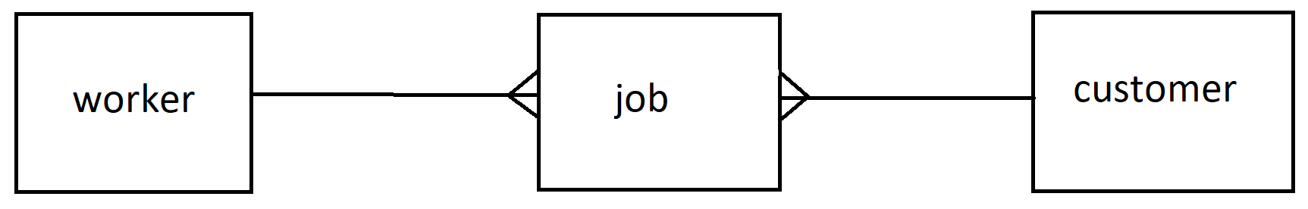

# worker

Any worker can create a login and profile (set as ‘worker’), including the services that they offer e.g. plumber (selected from the ‘services’ drop down). They will need to provide availability which can be expressed as slots in a calendar. These slots can be implemented as one ‘job’ each without a customer or time applied to it.

# customer

A ‘customer’ can create a log and profile (set as ‘customer’). The same registration page and login mechanism can be used here as with the ‘worker’. They can make a selection via the ‘services’ drop down, and then select a time. The time can be a preselected dropdown populated by looking at the available workers for example.

# job

When the worker makes a selection, we can automatically create an appointment for a worker, or ask for the worker to verify and so on, but basically fills in the details for that ‘job’.

# Implementation

This program is best written with a database as there is strong coupling of information.

If a simpler design is desired, please feel free to adapt.

Any amount of complexity can be built on top of this for example by:

* Extending the database to include more information
* Writing responsive CSS for different devices
* Sending messages to people making them aware of status updates (e.g. new appointment)

# Additional things to think about

Hashing passwords

Sessions (security restrictions)

Error handling

User interface / Experience

Testing

Documentation (User guide / walkthrough && readme)

Responsive CSS

# Technologies

Angular

C# (Visual Studio web app project)

SQL Server

# Alternatives

The same basic structure can be used to do a ‘doctor appointment booking system’ where a doctor is a ‘worker’ the patient is a ‘client’ and an appointment is a ‘job’.

https://codeshoppy.com/shop/product/doctor-appointment-booking-system/